**Authentication sequence diagram**

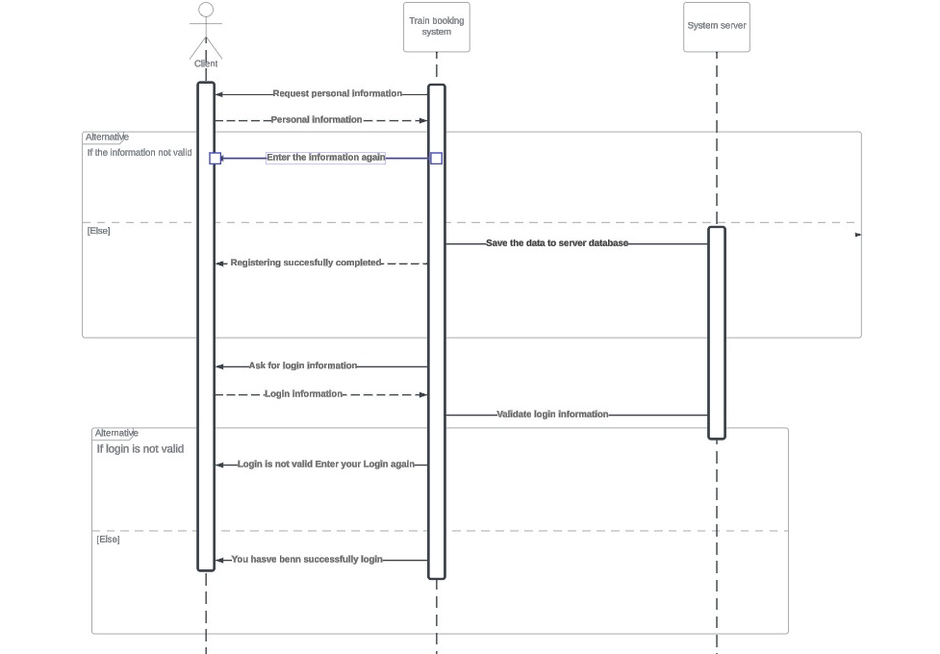

**Search for trips sequence diagram**

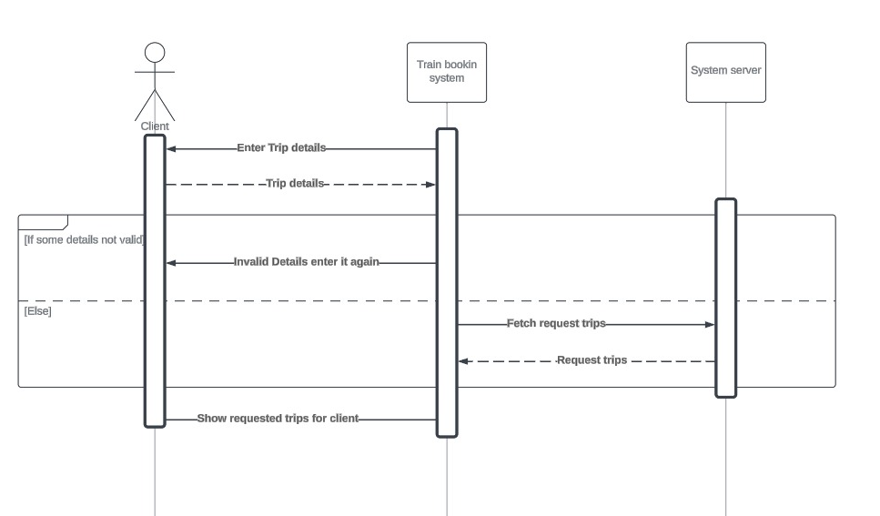

**Booking ticket sequence diagram**

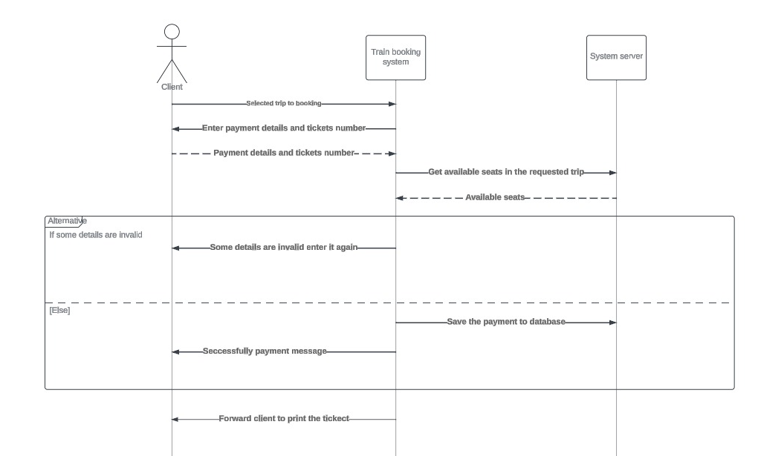

**CRUD operations sequence diagram**

